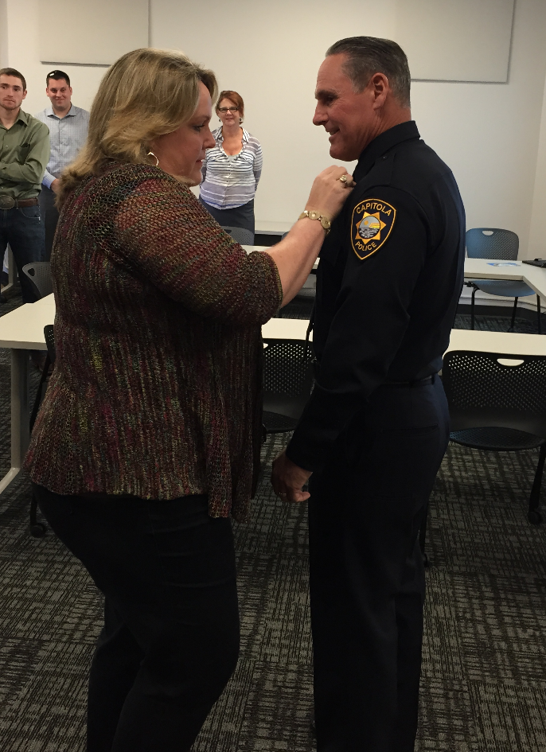
Capitola Reserve Police Officer sworn in
John Ferrara
Wednesday, April 20, 2016
John Ferrera is a lifelong resident of Santa Cruz County and a graduate of Soquel High School. He currently is a jail detention officer for the Santa Cruz County Sheriff's Office. John is also an active National Guard Reservist as a Lieutenant-Major. He is a graduate of the Police Academy and has been very active in Law Enforcement over the years. As a Police Reserve Officer, John will be in training and will be able to assist in our summer season. His wife Tracy is the City Clerk for the City of Scotts Valley. We welcome him and his family to the police department.

