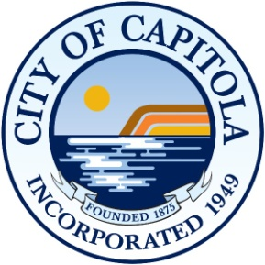

NOTICE OF PUBLIC HEARING
BEFORE THE CAPITOLA CITY COUNCIL
AMENDING THE CAPITOLA MUNICIPAL CODE
SECTION 9.30.020 (B), SURF SCHOOL REGULATIONS

NOTICE IS HEREBY GIVEN that a Public Hearing will be held before the City Council of the City of Capitola on Thursday, February 25, 2016, at 7:00 P.M. in the City Hall Council Chambers, 420 Capitola Avenue, Capitola, California, for the consideration of an Ordinance amending Capitola Municipal Code (CMC) Section 9.30.020 (b), Surf School Regulations.

Interested persons are invited to attend and be heard at the Public Hearing. Testimony may be presented in person or submitted in written form prior to the hearing and made a part of the hearing record.

If you require special assistance in order to attend the meeting, including needs addressed by the Americans with Disabilities Act, please notify the City at least 3 days prior to the meeting by calling (831) 475-7300.

Copies of the proposed fee schedule and further information on this subject may be obtained from the Office of the City Clerk, 420 Capitola Avenue, Capitola, CA 95010.

CITY OF CAPITOLA

DATED: February 11, 2016 Susan Sneddon, CMC
City Clerk

