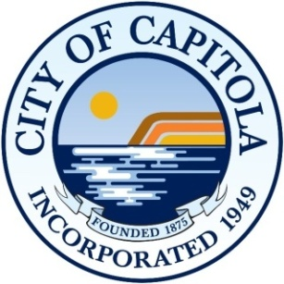 | AGENDA  commission on the environment  Wednesday, October 19, 2022  6:00 PM  Capitola City Hall, Community Room  420 Capitola Avenue  Capitola CA 95010

PLEASE NOTE THIS IS AN IN-PERSON MEETING
NO REMOTE ACCESS WILL BE PROVIDED

Call to Order and roll call
Commissioners: Michelle Beritzhoff-Law, Chair, Bryce Ebrahimian, Margaux Keiser, Meredith Keet, Jason Shepardson, Peter Wilk

INTRODUCATION: Jessica Kahn, Public Works Director

ORAL & WRITTEN COMMUNICATIONS
The Chair may announce and set time limits at the beginning of each agenda item. The Committee Members may not discuss Oral Communications to any significant degree but may request issues raised be placed on a future agenda.

APPROVAL OF MINUTES – September 21, 2022

GENERAL BUSINESS
- Presentation: Capitola 2020 GHG Inventory – Amary Berteaud, Sustainability Program Manager, AMBAG

ITEMS FOR FUTURE AGENDAS

ADJOURNMENT to November 16, 2022

The Commission on the Environment meets monthly 6:00 PM.

Agenda and Agenda Packet Materials: The Commission on the Environment Agenda is available on the City's website: www.cityofcapitola.org/ on Friday prior to the Wednesday meeting. If you need additional information, please contact the Public Works Department at (831) 475-7300.

Americans with Disabilities Act: Disability-related aids or services are available to enable persons with a disability to participate in this meeting consistent with the Federal Americans with Disabilities Act of 1990. Assisted listening devices are available for individuals with hearing impairments at the meeting in the City Council Chambers. Should you require special accommodations to participate in the meeting due to a disability, please contact the City Clerk’s office at least 24-hours in advance of the meeting at 831-475-7300. In an effort to accommodate individuals with environmental sensitivities, attendees are requested to refrain from wearing perfumes and other scented products.

