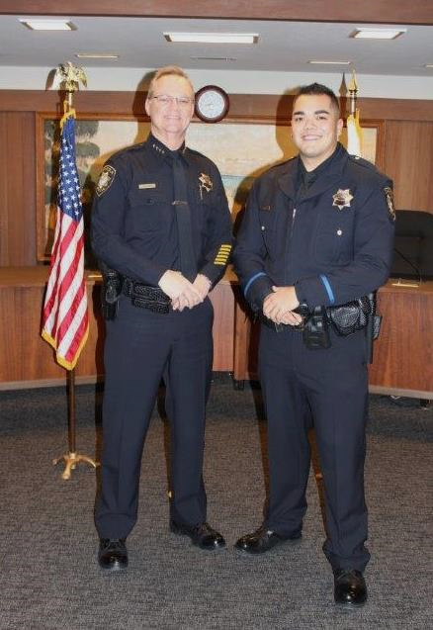
Capitola Police Officer
ZACK CURRIER
sworn in on January 27, 2017
The Capitola Police Department is proud to announce that Zack Currier was recently sworn in as a new police officer. Zack is 23 years old, was born in San Jose, and raised in a law enforcement family in Corralitos. Zack graduated from Monte Vista Christian High School and is currently attending Cabrillo College. Prior to becoming a Capitola police officer, Zack spent two years with the Santa Cruz Sheriff’s Office as a correctional officer. In his spare time, Zack enjoys all outdoor activities including archery and hunting. We are proud to welcome Zack Currier to our City of Capitola family.

